Directions for the Ad Hoc Promotion Committee Chairman
The Ad Hoc Promotion Committee is formed by the VRGSSR with one chairman and 4 members. The VRGSSR seeks willingness of the volunteers. After accepting the willingness to work as a promotion committee chairman, the chairman and all the promotion committee members receive an acknowledgment email sent by the VRGSSR through the online system. Now, the Promotion Committee chairman can log on to the online system and can open the electronic promotion application. The following is a list of items to be considered by the Promotion Committee (PC) Chairman for promotion request of a faculty member:
1- Discuss promotion application with meeting with all the members of the promotion committee
2- Review the comments provided by the external reviewers
2- Make a promotion committee report and let it signed by all the members
The online System facilitates the PC Chair to perform all the above mentioned tasks. Following are the screen shot of all the activities the PC Chairman is supposed to perform after logging on to the system
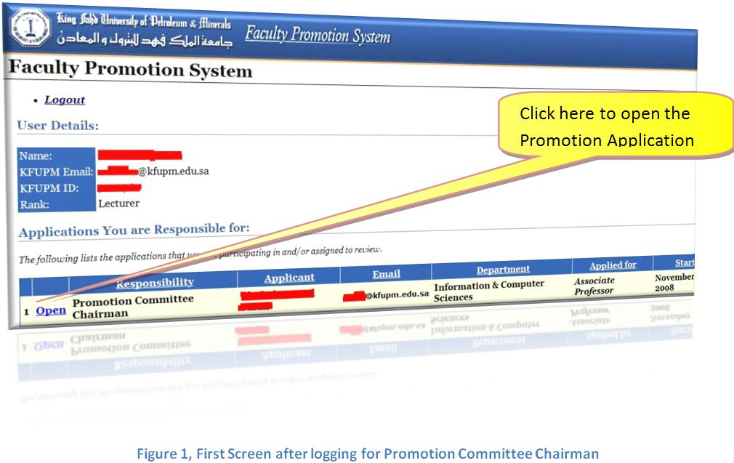

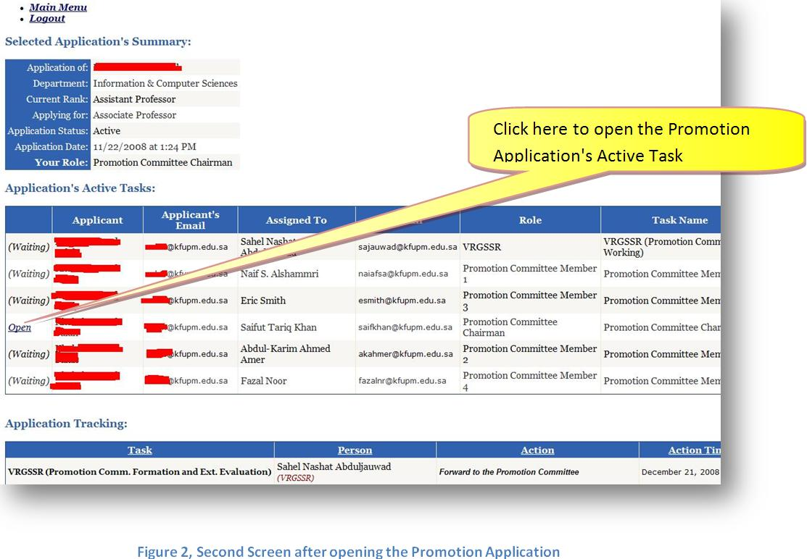
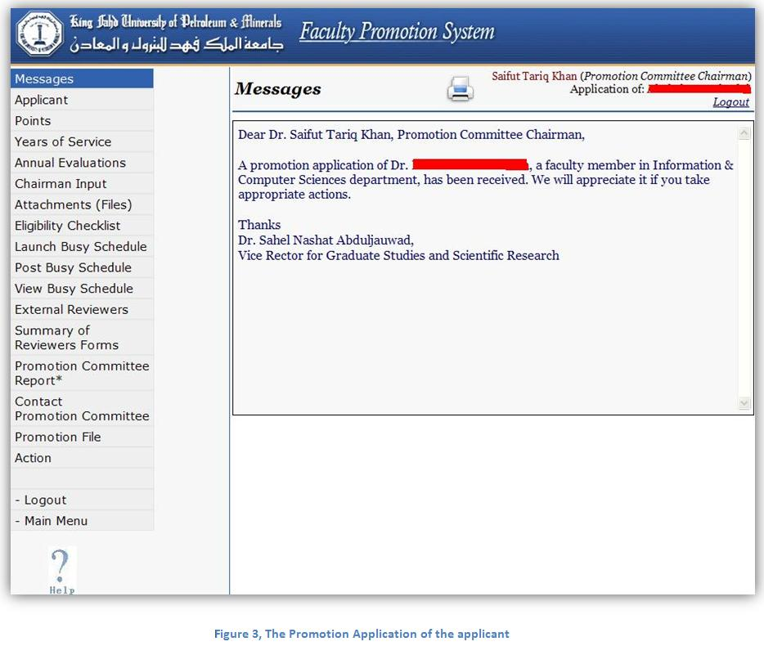
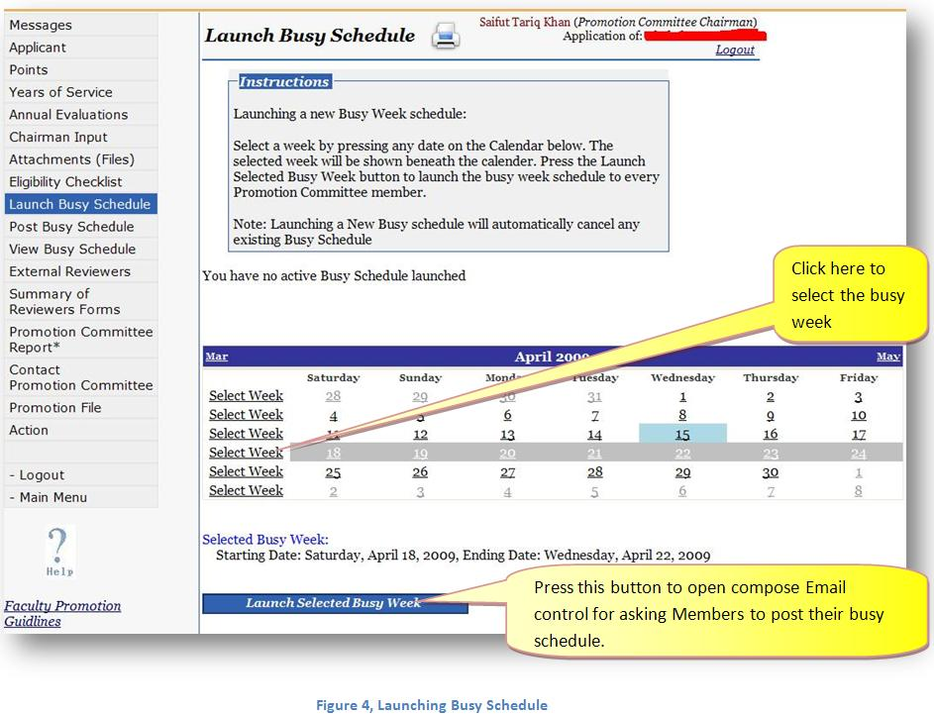
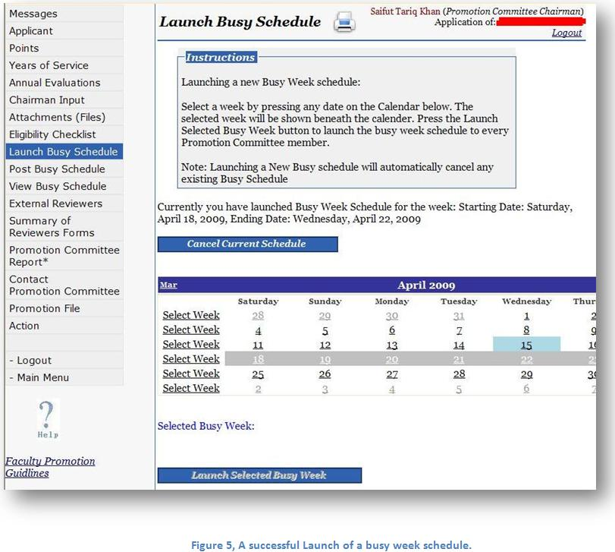
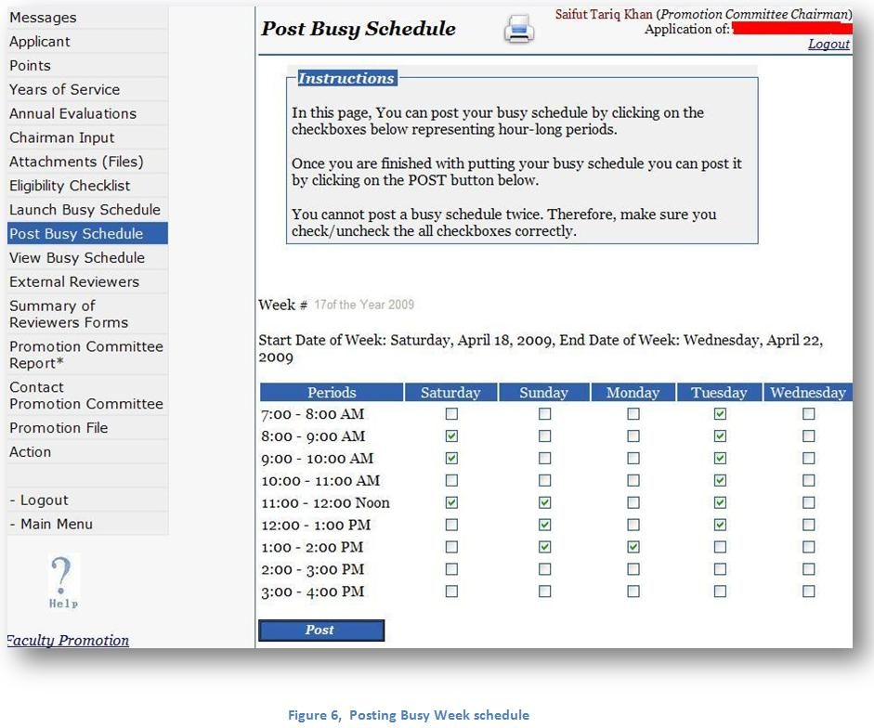
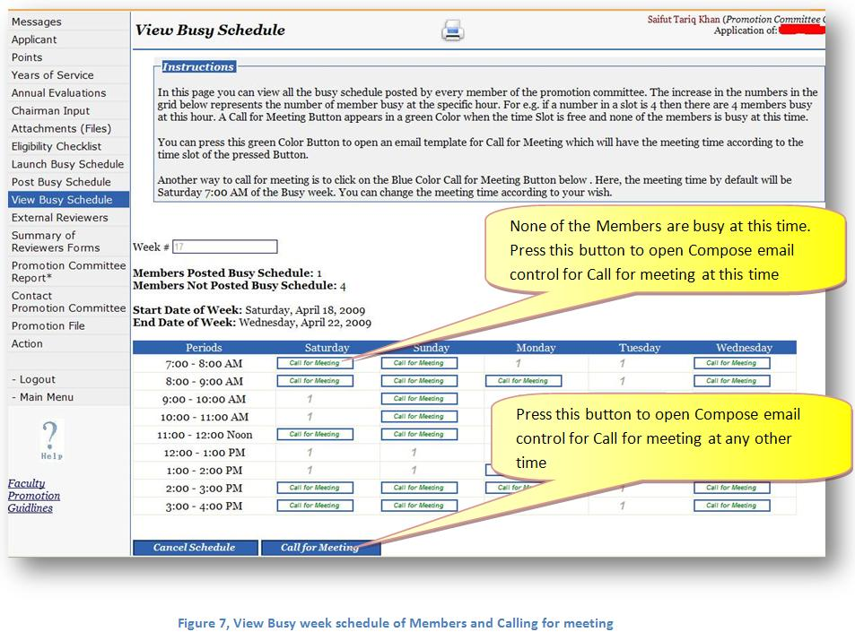
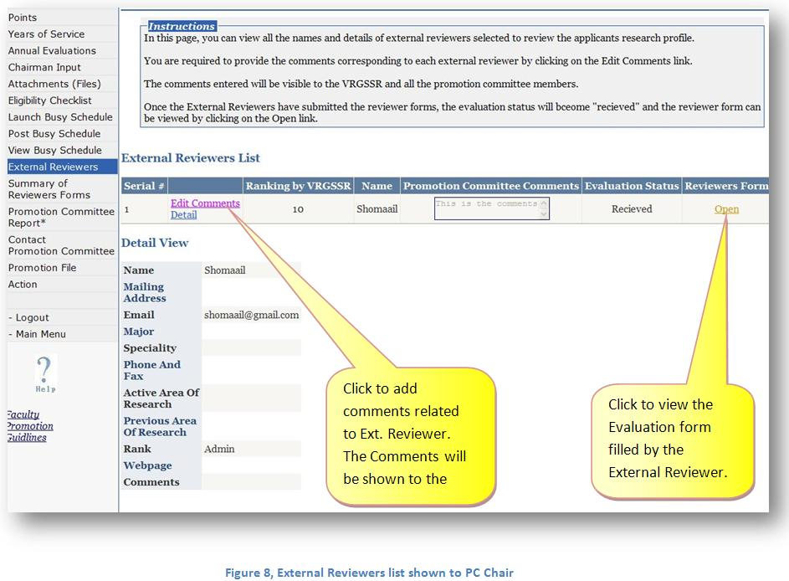
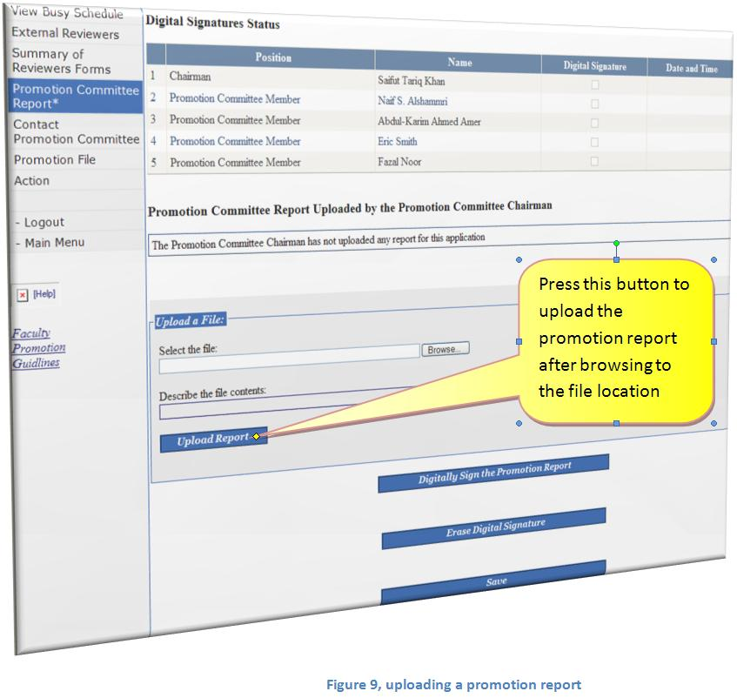
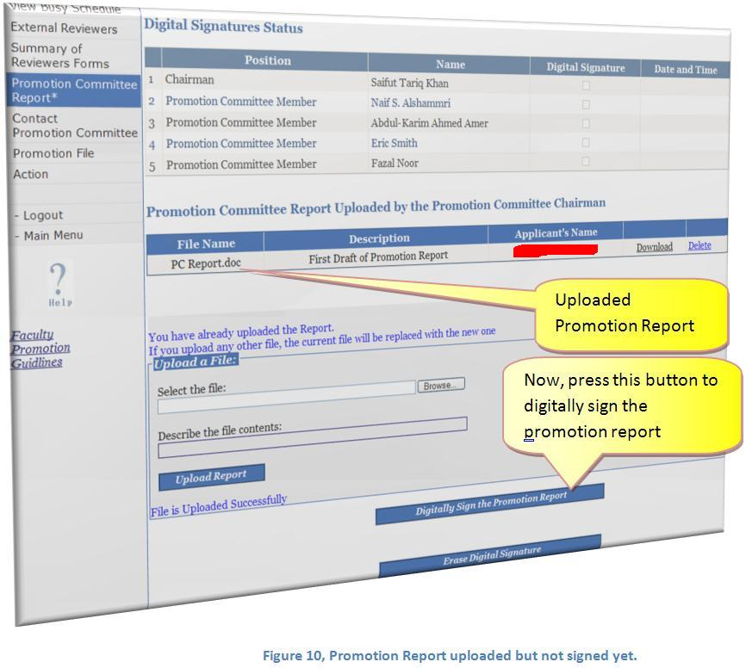
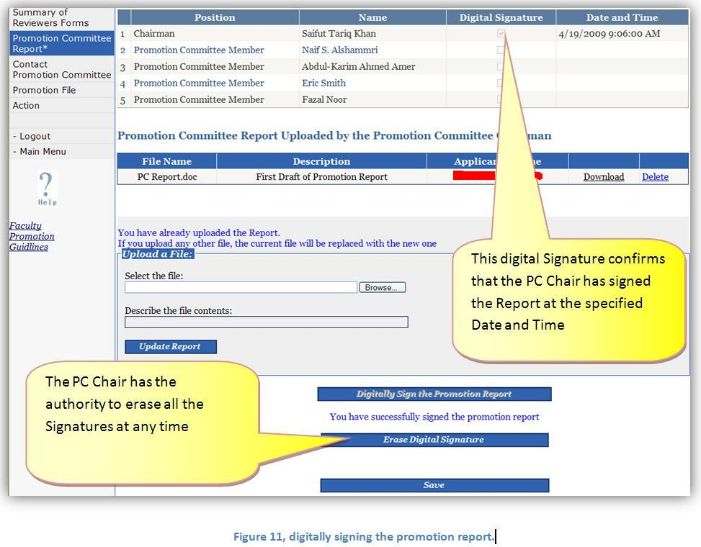
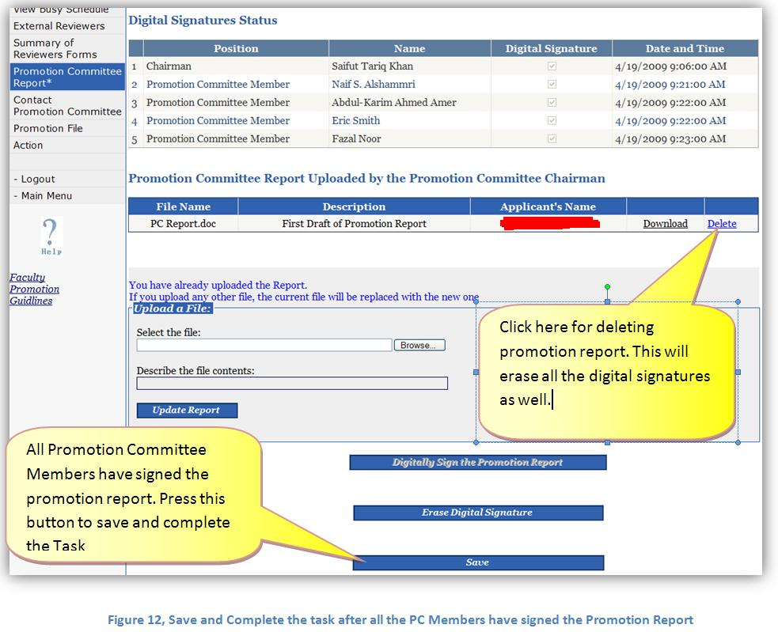
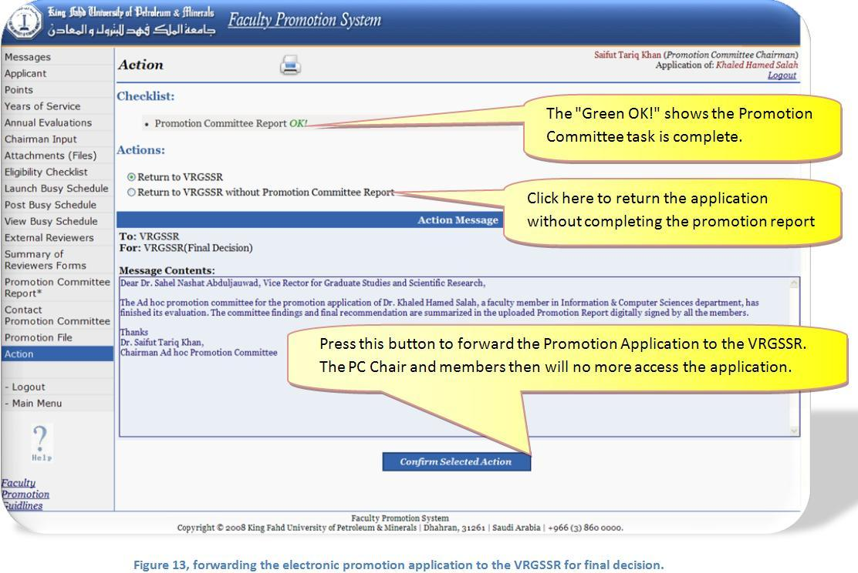
The Promotion Committee Chairman can do things simultaneously and fill different forms and modify his input at any stage, as long as the form has not been returned to the VRGSSR.

